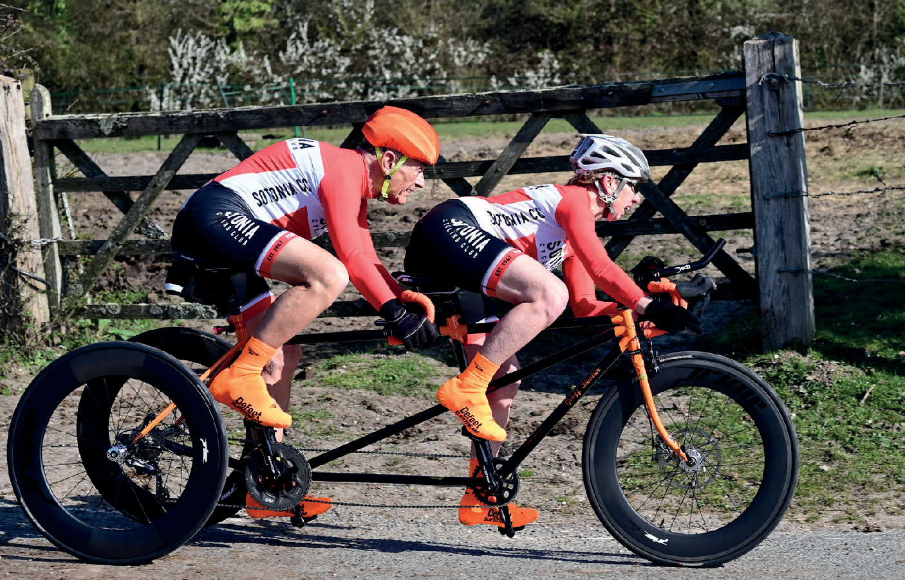

**Open 10 Mile Time Trial**

**Results**

**Sunday 14th July 2024 | Course P612/10**

**Promoted for and on behalf of Cycling Time Trials under their Rules and Regulations**

**Timekeepers:** Mary Corbett, Norman Harvey, Dave Crocker

Sotonia CC

**Recorder:**

**Organiser:** Graham Harman 16 Woodman Close, Sparsholt, Winchester, Hants, SO21 2NT

Marsharls: Julian Gee, Niamh Harman, Pete Jennings



Refreshments: Carron Harman, Ciara Harman

Many Thanks to everyone for helping out, dream team.

Well done to everyone that achieved a PB. Hope to see you again next year.

RESULTS:

Fastest Men

1. Jamie Whitcher 17.47 Course Record and PB
2. Matthew Buckley 18.56 PB
3. Howard Bailey 19.05 PB

Fastest Women

1. Sarah Matthews 21.25 PB
2. Kirsty Mcseveny 22.50
3. Caroline Nottage 23.23 PB

Fastest Road Bike

1. Tom Nancarrow 19.14 PB
2. Jacob Crossley 21.26 PB
3. James Horton 21.29

Fastest Vet on STD

1. Sarah Matthews 09.28
2. Colin McDermott 08.15
3. Peter Main 08.12

Apologies to Sarah for my mistake when announcing this category

Fastest Team

VC St Rapheal

Matthew Buckley, Adrain Talley, Stuart Peckham

|  |  |  |  |  |  |  |  |  |
| --- | --- | --- | --- | --- | --- | --- | --- | --- |
| **1** | TT Bike | Jamie | Whitcher | Open | Bournemouth Cycleworks - Vitec Fire - Ford Civil - Trek | 00:17:47 | PB |  |
| **2** | TT Bike | Matthew | Buckley | Open | Velo Club St Raphael | 00:18:56 | PB |  |
| **3** | TT Bike | Howard | Bayley | Open | ...a3crg | 00:19:05 | PB |  |
| **4** | TT Bike | Larry | Wiltshire | Open | Racing Club Ravenna | 00:19:08 | PB |  |
| **5** | TT Bike | Colin | McDermott | Open | Festival Road Club | 00:19:09 | PB |  |
| **6** | TT Bike | Max | Webber | Open | Andover Wheelers | 00:19:10 | PB |  |
| **7** | Road Bike | Tom | Nancarrow | Open | Poole Wheelers Cycling Club | 00:19:14 | PB |  |
| **8** | TT Bike | Peter | Main | Open | 34 Nomads CC | 00:19:27 |  |  |
| **9** | TT Bike | Lee | Williams | Open | FTP ( Fulfil The Potential ) Race Team | 00:19:39 |  |  |
| **10** | TT Bike | Stuart | Hourigan | Open | VeloRefined Rule 5 | 00:20:07 |  |  |
| **11** | TT Bike | Mitchell | Webber | Open | Andover Wheelers | 00:20:08 |  |  |
| **12** | TT Bike | Adrian | Talley | Open | Velo Club St Raphael | 00:20:09 | PB |  |
| **13** | TT Bike | Steven | Pink | Open | Poole Wheelers Cycling Club | 00:20:18 |  |  |
| **14** | TT Bike | Jamie | Richardson Paige | Open | Magspeed Racing | 00:20:32 | PB |  |
| **15** | TT Bike | Gary | Fouracres | Open | Yeovil Cycling Club | 00:20:58 |  |  |
| **16** | TT Bike | Sarah | Matthews | Female | ...a3crg | 00:21:25 | PB |  |
| **17** | Road Bike | Jacob | Crossley | Open | CGC | 00:21:26 | PB |  |
| **18** | Road Bike | James | Horton | Open | Wessex Road Club | 00:21:29 |  |  |
| **19** | TT Bike | Graeme | Browning-Martin | Open | New Forest CC | 00:21:30 | PB |  |
| **20** | TT Bike | Stuart | Peckham | Open | Velo Club St Raphael | 00:21:35 |  |  |
| **21** | TT Bike | Alexander | Paul | Open | NAUT Cycling | 00:22:00 |  |  |
| **22** | TT Bike | Will | Goddard | Open | Sotonia CC | 00:22:02 | PB |  |
| **23** | TT Bike | Chris | Hill | Open | Poole Wheelers Cycling Club | 00:22:09 | PB |  |
| **24** | TT Bike | Michael | Naulls | Open | Velo Club Venta | 00:22:34 |  |  |
| **25** | TT Bike | Kirsty | Mcseveney | Female | ...a3crg | 00:22:50 |  |  |
| **26** | TT Bike | Caroline | Nottage | Female | Army Cycling | 00:23:23 | PB |  |
| **27** | TT Bike | Oliver | Berney | Open | Utag RT | 00:23:28 |  |  |
| **28** | TT Bike | Michael | Harrison | Open | North Hampshire RC | 00:23:31 |  |  |
| **29** | TT Bike | Rebecca | Hughes | Female | Poole Wheelers Cycling Club | 00:23:41 | PB |  |
| **30** | TT Bike | Jason | Maule | Open | Somer Valley Cycling Club | 00:23:55 | PB |  |
| **31** | Road Bike | Stephen | Skinner | Open | Velo Club St Raphael | 00:23:58 |  |  |
| **32** | TT Bike | Gary | Chiverton | Open | Bournemouth Jubilee Whs | 00:24:02 |  |  |
| **33** | TT Bike | Mike | Boyce | Open | ...a3crg | 00:24:12 |  |  |
| **34** | TT Bike | Simon | Craig-McFeely | Open | ...a3crg | 00:24:41 |  |  |
| **35** | TT Bike | Russ | Osborn | Open | New Forest CC | 00:24:52 | PB |  |
| **36** | Road Bike | Alan | Davies | Open | Hampshire Road Club | 00:25:30 | PB |  |
| **37** | TT Bike | Chris | Summers | Open | Sotonia CC | 00:26:15 |  |  |
| **38** | TT Bike | David | England | Open | Crabwood Cycling Club | 00:26:32 |  |  |
| **39** | Road Bike | Peter | Pike | Open | Sotonia CC | 00:26:38 |  |  |
| **40** | TT Bike | Pete | Wilson | Open | Bournemouth Arrow CC | 00:29:08 |  |  |
| **41** | Road Bike | Robert | Jolliffe | Open | New Forest CC | 00:32:18 |  |  |
|  | TT Bike | Richard | Scott | Open | Somer Valley Cycling Club |  | DNS |  |
|  | TT Bike | Malcolm | Cox | Open | Velo Club St Raphael |  | DNSA |  |
|  | TT Bike | Matt | Doe | Open | ...a3crg |  | DNS |  |
|  | TT Bike | Samuel | Wadsley | Open | Poole Wheelers Cycling Club |  | DNS |  |
|  | TT Bike | Simon | Berogna | Open | Velo Club St Raphael |  | DNSA |  |
|  |  |  |  |  |  |  |  |  |